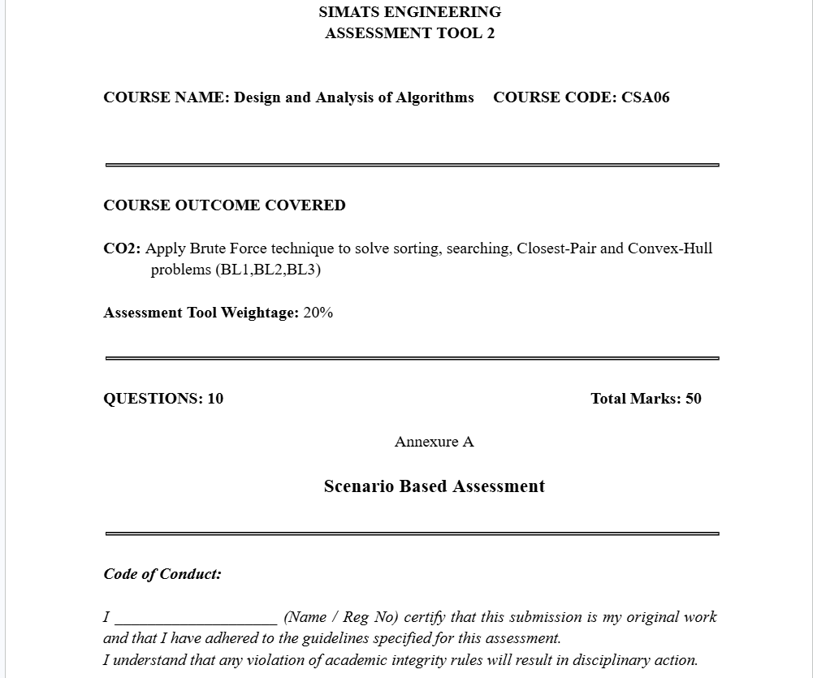

2. A logistics company manages 500 warehouse locations. To optimize delivery routes, the system calculates the distance between every pair of warehouses to identify the closest pair. As the number of warehouses increases, the system becomes slower.
a) Explain how the brute-force approach works in this case.
b) Derive the time complexity.
c) Discuss why scalability is an issue.

a) Brute-force approach

In the brute-force approach, the system calculates the distance between every possible pair of the 500 warehouse locations.

Steps:

Take the first warehouse and calculate its distance to all other warehouses.
Move to the second warehouse and calculate its distance to the remaining warehouses.
Continue until all unique pairs have been checked.
Compare all calculated distances and select the pair with the smallest distance.

For 500 warehouses, the number of distance calculations is:

500
×
499
2
=
124
,
750
pairs

b) Time complexity

For n warehouses:

The first warehouse compares with n − 1 warehouses.
The second compares with n − 2 warehouses.
This continues until the last warehouse.

Total comparisons:

(
𝑛
−
1
)
+
(
𝑛
−
2
)
+
⋯
+
1

=
𝑛
(
𝑛
−
1
)
2

Ignoring constants and lower-order terms:

𝑇
(
𝑛
)
=
𝑂
(
𝑛
2
)

Time Complexity: O(n²)

c) Why scalability is an issue

Scalability becomes a problem because the number of comparisons grows quadratically as the number of warehouses increases.

Examples:

500 warehouses: 124,750 comparisons
1,000 warehouses: 499,500 comparisons
10,000 warehouses: about 50 million comparisons

As the number of warehouses increases:

Processing time increases rapidly.
More CPU resources are required.
Route optimization becomes slower and less efficient.
The system may not meet real-time delivery planning requirements.

Therefore, the brute-force method is suitable only for small datasets. For large numbers of warehouses, more efficient algorithms (such as the Closest Pair of Points algorithm using Divide and Conquer, with O(n log n) time complexity) are preferred.

